

**Data Acquisition Software**

**User Manual**

**16/08/2020**

**Developed at the University of Strathclyde and Durham University**

|  |  |  |  |  |
| --- | --- | --- | --- | --- |
|  |  |  |  | www.vasotracker.com |

Table of Contents

1. Overview 2

VasoTracker

Citing VasoTracker

The VasoTracker data acquisition software

The VasoTracker Offline Analyzer

1. Installation 4

Hardware requirements

Supported cameras

Installation prerequisites

Installing VasoTracker

1. Running VasoTracker 6

Setting up a VasoTracker shortcut

Maximizing VasoTracker performance

Starting the VasoTracker Data Acquisition Software

1. VasoTracker Settings 9

The settings bar

Source control panel

Acquisition Settings control panel

Analysis Settings control panel

Outer and Inner Diameter Graph Settings control panel

Data Acquisition panel

Start/Stop panel

Image dimension panel

1. VasoTracker Data Export 14

Data export

Data entry table

1. Editing VasoTracker 15

Source code installation steps

Installing Prerequisites

Installing Python 2.7

Installing Python dependencies

Launching VasoTracker from the source code

# Overview

## VasoTracker

VasoTracker is an open source pressure myograph system for tracking the diameter of isolated, pressurized blood vessels. The complete system includes a vessel chamber, temperature controller, pressure monitor, microscope, camera, laptop computer, and analysis software – everything that is required to perform pressure myography.

We made VasoTracker because we wanted to make pressure myography more accessible (i.e. cheaper) and customizable. The full system costs ~$4500 (£3500 if you are in the UK). This is ~10% of the cost of a commercial myograph system. Visit the VasoTracker website ([www.vasotracker.com](http://www.vasotracker.com)) to find out how to build your own.

## Citing VasoTracker

We hope that VasoTracker is of use to you or anyone else wishing to study blood vessel function. Our work developing and releasing VasoTracker as an open source platform was made possible by grant funding from the Wellcome Trust and British Heart Foundation. Our ability to support, develop and maintain VasoTracker will depend on more grants, so whether you use the VasoTracker software and hardware as a complete system or only the certain bit, please cite VasoTracker in your scientific publications.

Penelope F. Lawton, Matthew D. Lee, Christopher D. Saunter, John M. Girkin, John G. McCarron and Calum Wilson (2019). VasoTracker, a low-cost and open source pressure myograph system for vascular physiology. Frontiers in Physiology 10:99.

DOI: <https://doi.org/10.3389/fphys.2019.00099>

## The VasoTracker data acquisition software

The VasoTracker data acquisition software was designed to monitor the diameter of blood vessels mounted in a pressure myograph. We developed the software to complement our own open source pressure myograph chamber, but it can be used to add diameter tracking capabilities to almost any microscope/camera set up. The software performs the following functions

* Live acquisition/display of pressurized arteries mounted in the VasoTracker vessel chamber.
* Real-time measurement and display of outer and inner artery diameter.
* Real-time measurement of bath temperature and intraluminal pressure.
* Live recording and graphing of artery diameter(s).
* Tracking of experimental manipulations (e.g. drug additions).
* Multi-line diameter tracking.
* Tracking within a user-specified region-of-interest (ROI).
* Line averaging and statistical filtering of result.
* Video output (.tiff files).

|  |  |
| --- | --- |
|  | The VasoTracker software is easy to adapt. Get in touch with us if you wish the software to calculate and output any other parameters (e.g. wall thickness, cross sectional area, media/lumen ratio). Alternatively, you can adapt the software yourself! |

## The VasoTracker Offline Analyzer

We also wrote some software for analyzing pre-recorded blood vessel data. Our offline analyzer can be used to assess vascular reactivity in blood vessels imaged using a variety of experimental techniques (pressure myography, fluorescence imaging, ultrasound). For more information and to download this software visit: <http://www.vasotracker.com/blood-vessel-diameter-software/>

# Installation

## Hardware requirements

|  |  |
| --- | --- |
|  | **VasoTracker is only compatible with 64-bit Windows operating systems.**  (well, we have only tested it on 64-bit operating systems) |

* Microsoft Windows 10 Pro 64-bit
* 8GB RAM minimum (preferably 16GB)
* Compatible USB camera (see below)

## Supported cameras

VasoTracker utilizes camera libraries provided by Micro-Manager (µManager) Open Source Microscopy Software (<https://micro-manager.org/>). If your camera works in µManager, then it should work with VasoTracker. We have fully tested, and use on our VasoTracker systems, the following cameras:

* Thorlabs DCC1545M USB 2.0 Camera
* OpenCV cameras
* FakeCamera – use to load your own images into VasoTracker

## Installation prerequisites

Before installing VasoTracker, the camera drivers, Arduino IDE, and µManager must be installed. For the Thorlabs DCC1545M camera:

* Download and run the camera driver software from the Thorlabs website: <https://www.thorlabs.com/software_pages/ViewSoftwarePage.cfm?Code=ThorCam>
* Download and install the latest Nightly Build of µManager from the µManager website: <http://valelab4.ucsf.edu/~MM/nightlyBuilds/1.4/Windows/>
* Download and install the Arduino IDE from the Aduino website:

https://www.arduino.cc/download_handler.php?f=/arduino-1.8.8-windows.exe

|  |  |
| --- | --- |
|  | **Ensure that µManager is installed to its default location:**  **(C:\Program Files\Micro-Manager-1.4)** |

## Installing VasoTracker

There are a number of options for installing VasoTracker:

Option 1 (easy installation method 1):

* Download and run the zipped MSI installer from the VasoTracker website: <http://www.vasotracker.com/software/>

Option 2 (easy installation method 2):

* Download the complete VasoTracker package from the GitHub repository: <https://github.com/VasoTracker/VasoTracker>
* Unzip the VasoTracker.zip package and navigate to the VasoTracker Software\VasoTracker1.x.x folder. Move or copy the folder to C:\Program Files.

|  |  |
| --- | --- |
|  | **We tried to make installing VasoTracker as simple as possible. But for reasons unknown to us, our installers fail on certain computer systems. If you are unlucky enough to own one of these, all is not lost. See Option 3 below!** |

Option 3 (not so easy installation method):

* Install the source code
* For instructions, refer to Editing VasoTracker (Page 15)

|  |  |
| --- | --- |
|  | **Choosing Option 3 will allow you to edit the VasoTracker code** |

# Running VasoTracker

|  |  |
| --- | --- |
|  | **VasoTracker may have been updated since this section was written.**  If it has, we should be updating these instructions soon. If you have any queries,  send an email to vasotracker@gmail.com. |

## Setting up a VasoTracker shortcut

To set up a desktop shortcut:

* Navigate to the VasoTracker installation folder on your computer (the default location should be C:\Program Files\VasoTracker).
* Right click on the VasoTracker.exe
* Click “Send to”
* Click “Desktop”
* This action creates a desktop shortcut to the file or folder on your desktop.
* Make VasoTracker run in administrator mode (this ensures VasoTracker can save data files wherever you specify):
  + Right-click the desktop shortcut, click “Advanced”, then check “Run as administrator”

## Maximizing VasoTracker performance

We run VasoTracker on a number of different computer systems, on our less-able computers the following actions help performance:

* Using the “High Performance” Windows 10 power plan: https://help.ableton.com/hc/en-us/articles/115000211304-How-to-disable-power-throttling-on-Windows
* Disabling Windows USB Selective Suspend: <https://www.windowscentral.com/how-prevent-windows-10-turning-usb-devices%3famp>
* Preventing Windows shutting off power to USB root hub: <https://www.pcworld.com/article/3045567/how-to-keep-charging-your-usb-devices-past-your-pcs-bedtime.html>

## Starting the VasoTracker Data Acquisition Software

VasoTracker can be launched by any of the following methods:

* Double-clicking the desktop shortcut (created above).
* Double-clicking VasoTracker.exe in the installation folder
* Running VasoTracker.py from the python command line.

Upon launching, the VasoTracker software will prompt the user to create a .csv file for saving data. A “Save As” dialogue box will appear. The file name field is automatically populated with the current date in the default “Results” folder. However, the user may change the folder location and the filename.

|  |  |
| --- | --- |
|  | **If a csv file with the same name already exists, a warning will pop up and the user will be asked to confirm whether the existing file is to be replace. Selecting “Yes” will erase all data in the original file!** |

Once a save file has been created, VasoTracker will then launch with the default settings and you will be presented with the layout shown below.

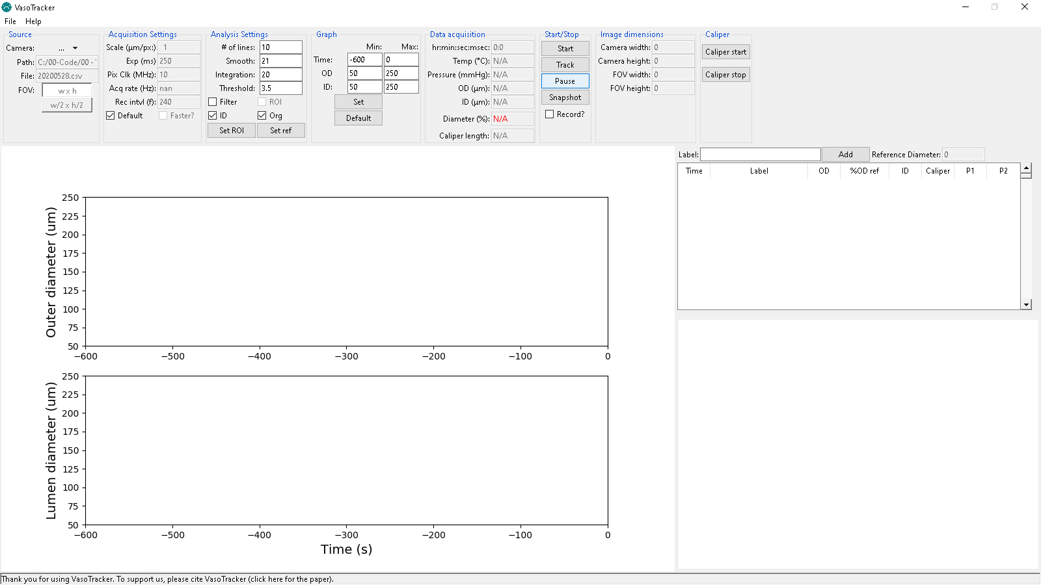

**Figure 1 – VasoTracker start screen**

### Demo Camera Mode

To familiarize users with the VasoTracker Data Acquisition Software, VasoTracker comes bundled with a fake/virtual camera adapter. This virtual camera adapter loads an example video recording of a pressurized artery and displays data as if a real camera is connected.

To run VasoTracker in Demo Mode:

* Enable the Virtual Camera by select “FakeCamera” in the “Source” panel.
* Start the virtual image acquisition by clicking “Start” in the “Start/Stop” panel.
* Begin diameter tracking by clicking “Track” in the “Start/Stop” panel.
* Once diameter tracking has initiated, diameter indicators will be overlaid on the camera feed box (Figure 2) and both inner and outer diameter will be plotted on the live graphs.

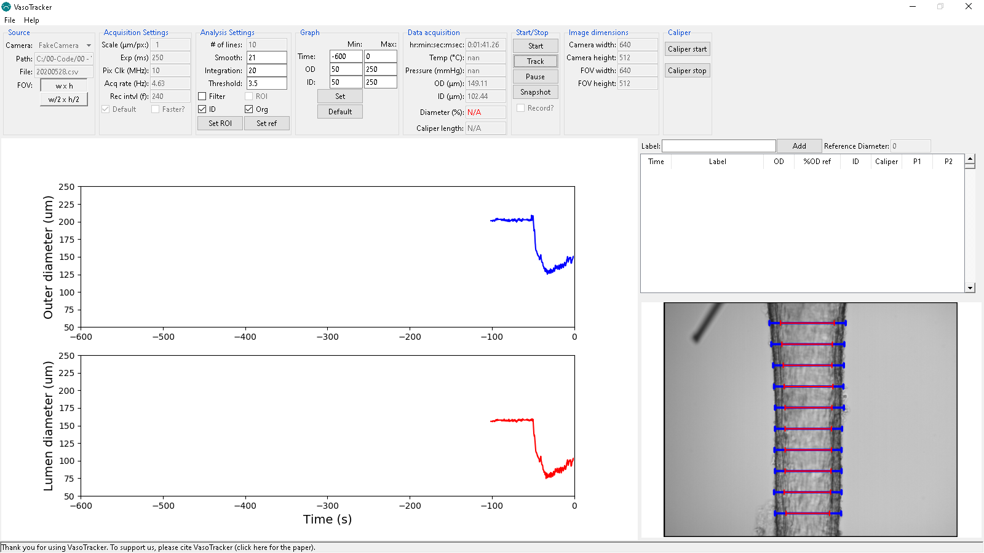

**Figure 3 – Virtual Camera Mode with diameter tracking**

### Live Camera Mode

To run VasoTracker in live mode (i.e. acquiring images from a real camera)

* Load your camera by select “Thorlabs” or other camera driver in the “Source” panel.
* Start the image acquisition by clicking “Start” in the “Start/Stop” panel.
* Begin diameter tracking by clicking “Record” in the “Start/Stop” panel.

# VasoTracker Settings

|  |  |
| --- | --- |
|  | **VasoTracker may have been updated since this section was written.**  If it has, we should be updating these instructions soon. If you have any queries,  send an email to vasotracker@gmail.com. |

## The settings bar

All of the acquisition and analysis settings can be altered in the settings bar. The settings bar also displays some handy information. Default settings can be changed by editing “default_settings.ini” in the root folder.

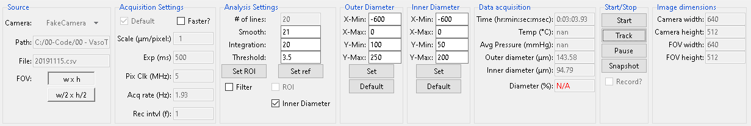

**Figure 4 – VasoTracker settings bar**

## Source control panel

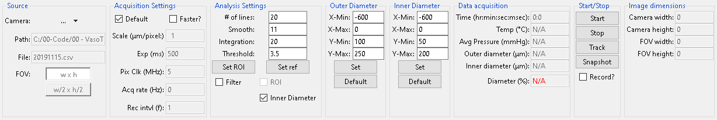

**Figure 5 – Source settingsCamera:** Select your camera here. If you are using a non-standard camera (you must have a working µManager config file), select µManagerCam. To use µManagerCam you mist place your µManager config file in the VasoTracker installation folder.

**Path:** displays the path to the current working directory.

**File:** displays the output file name.

**FOV:** buttons to set the field-of-view. This will only work for some cameras.

## Acquisition Settings control panel



**Figure 6 – Acquisition settingsDefault:** Enable/disable the default acquisition settings

**Faster?:** Enable/disable faster data acquisition here. This is still experimental.

**Scale:** Set the image calibration here. The default value of one will output diameter value in pixel units.

**Exp:** Set the camera exposure here.

**Pix Clk:** set the camera pixel clock here. We have only tested this with the Thorlabs camera. It allows more control over the exposure and frame rate.

**Acq rate:** displays the current acquisition rate.

**Rec intvl:** Set the interval (in frames) for exporting images here.

## Analysis Settings control panel

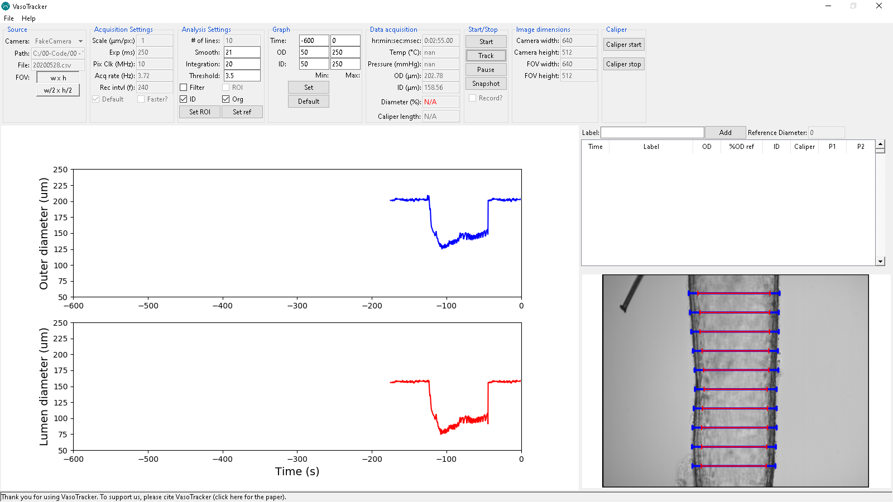

**Figure 7 – Analysis settings# of lines:** Set the number of scan lines here.

**Smooth:** Set how much smoothing is applied to intensity profiles (will improve wall detection).

**Integration:** Set the number of pixel lines over which diameter is integrated.

**Threshold:** Set threshold value for identifying outliers

**Set ROI:** Click here to draw an ROI on the display feed, diameter measurement will be limited to this ROI.

**Set ref:** Click here to set the current diameter as a reference value

**Filter:** Enable/disable outlier filtering

**ROI:** Enable/disable the ROI function.

**ID:** enable/disable inner diameter detection

**Org:** Slight modification of the tracking algorithm

|  |  |
| --- | --- |
|  | **When editing settings, you must confirm the values entered by hitting the “Enter” button on your keyboard.** |

## Outer and Inner Diameter Graph Settings control panel



**Figure 8 – Graph settingsTime:** Set the x-axis (time) limits

**OD:** Set the outer diameter axis limits.

**ID:** Set the inner diameter axis limits.

**Set:** Click here to allow an ROI to be drawn on the display feed, diameter measurement will be limited to this ROI.

**Default:** Click here to set the corresponding graph limits to default values.

|  |  |
| --- | --- |
|  | **All changes to graph settings must be confirmed by hitting the “Enter” button on your keyboard.** |

## Data Acquisition panel

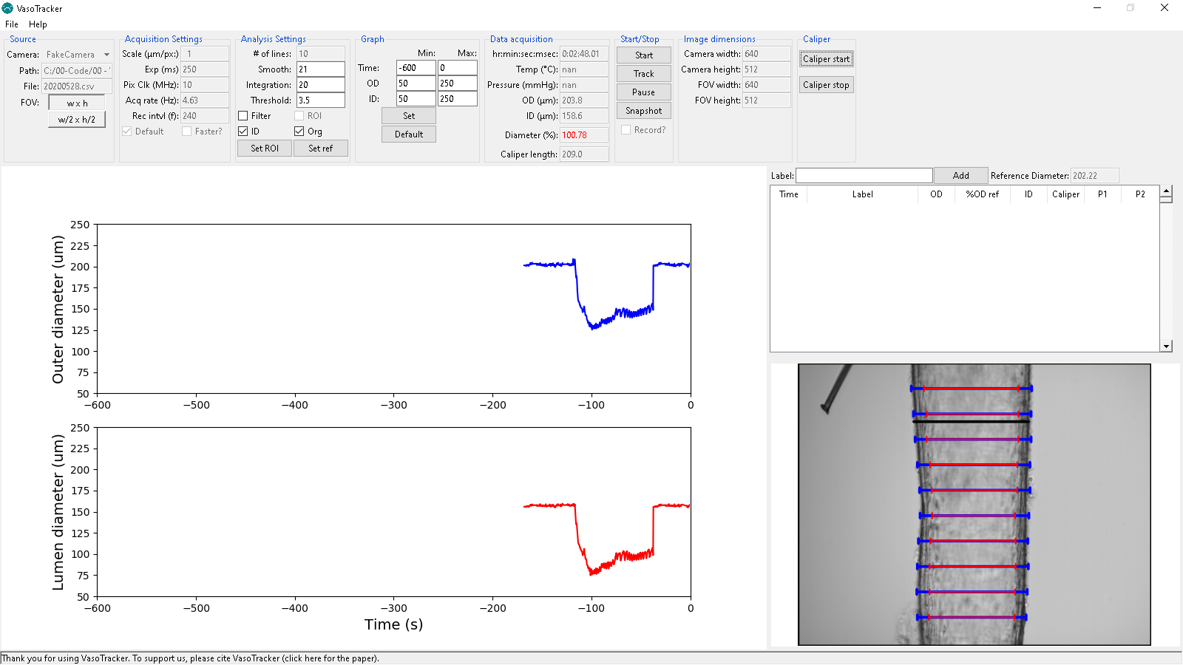

**Figure 9 – Data displayTime:** Displays the elapsed time (zeroed at beginning of experiment.

**Temp:** Displays the current temperature (from VasoTracker temperature controller).

**Avg Pressure:** Displays the vessel pressure (average of readings from VasoTracker pressure sensor).

**Outer diameter:** Displays the current inner diameter.

**Inner diameter:** Displays the current inner diameter.

**Diameter:** Displays the current (outer) diameter as a percentage of the reference diameter.

**Caliper length:** Displays the length of the manual caliper.

## Start/Stop panel



**Figure 10 – Start/stop panelStart:** Starts image acquisition.

**Track:** Starts the diameter tracking function.

**Pause:** Pauses diameter tracking (this enables settings to be altered).

**Snapshot:** Saves a snapshot of the current image display (with and without diameter indicators).

**Record?:** Enables/disables saving the image feed.

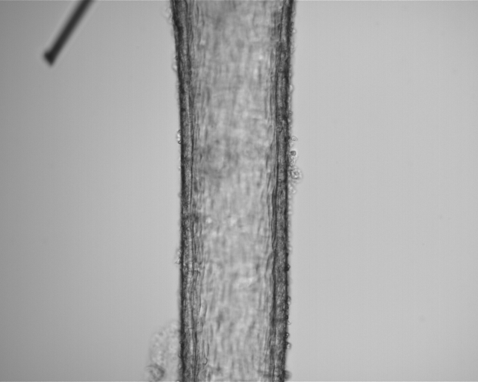 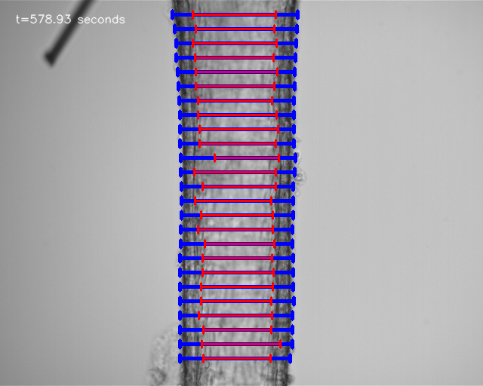

**Figure 11 – Example saved images without (middle) and with (right)diameter indicators overlaid.**

## Image dimension panel



**Figure 12 – Image dimensions**

**Camera width:** Displays the width (in pixels) of the camera chip.

**Camera height:** Displays the height (in pixels) of the camera chip.

**FOV width:** Displays the width (in pixels) of the current field-of-view.

**FOV height:** Displays the height (in pixels) of the current field-of-view.

## Image dimension panel



**Figure 12 – Image dimensions**

**Caliper start:** pauses image acquisition so that a manual caliper can be drawn on the image

**Caliper stop:** Does nothing at the moment.

## Pressure control panel



**Figure 12 – Image dimensions**

**Device:** National Instrument device ID

**ao channel:** Analogue out channel for NI device

**Set pressure:** Desired pressure for servo control

**Start Protocol:** Starts the pressure protocol defined in “default_settings.ini”

**Stop Protocol:** Stops the pressure protocol defined in “default_settings.ini”

# VasoTracker Data Export

## Data export

All data is saved automatically. On launching VasoTracker, the user is asked to create a .csv file. At each time point, all experimental parameters (time, average, diameter, pressure, temperature, etc.) are appended to the CSV file.

**Individual scanline measurements:**

The outer and inner diameter measurements of all scan lines are saved in separate CSV files (“…profiles.csv”).

**Spurious measurements:**

Whether or not the filtering algorithm is active, all scanline measurement are checked for spurious results. Indicators are saved in the “Flags.csvfiles. ” (1 indicates a good measurement, 0 indicates a spurious measurement). If the filtering algorithm is activated, spurious measurements are not included in the average calculations.

## Data entry table

VasoTracker also includes a data entry table (Figure 13). The table allows the user to enter details of any experimental manipulations and provides a convenient measure of arterial tone at the time of each entry. Any data entered into the Data Entry Table (See below) is saved as an additional .csv file, “…tables.csv”.

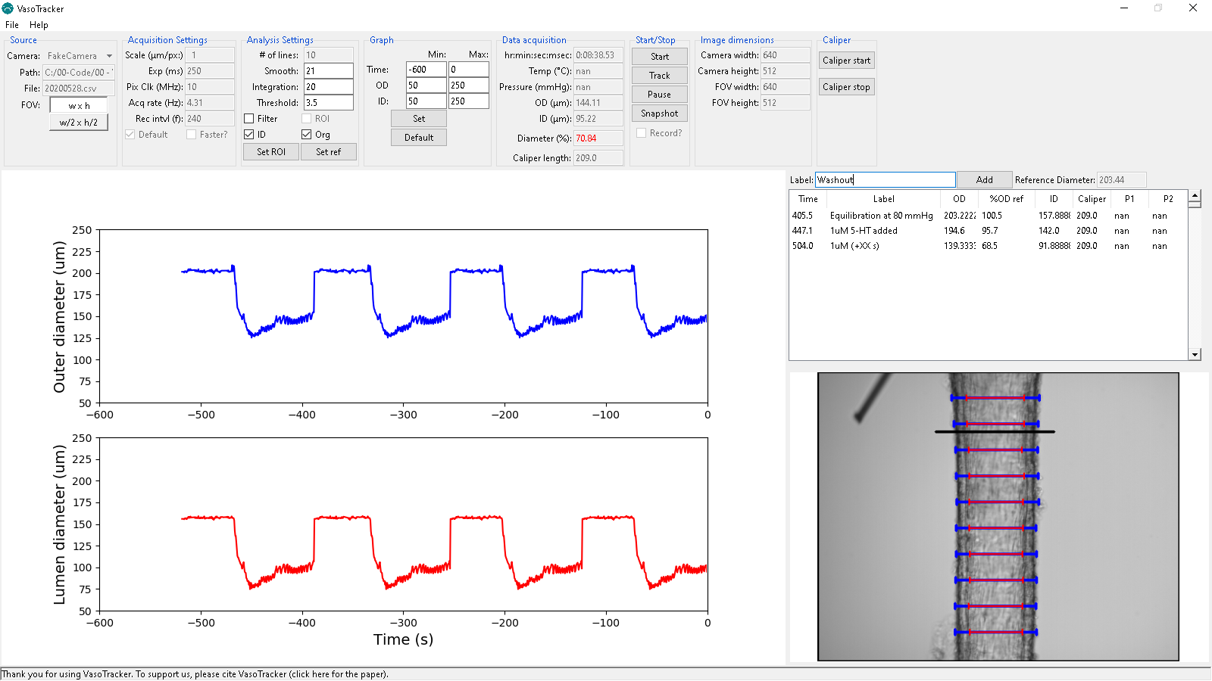

**Figure 13 – Data entry table**

# Editing VasoTracker

VasoTracker is written entirely in the Python programming language. Anybody can edit it in any way they see fit.

## Source code installation steps

* Install the prerequisites
* Install Python 2.7 (Anaconda distribution)
* Install Python dependencies

## Installing Prerequisites

Before installing VasoTracker, the camera drivers, Arduino IDE, and µManager must be installed. For the Thorlabs DCC1545M camera:

* Download and run the camera driver software from the Thorlabs website: <https://www.thorlabs.com/software_pages/ViewSoftwarePage.cfm?Code=ThorCam>
* Download and install the latest Nightly Build of µManager from the µManager website: <http://valelab4.ucsf.edu/~MM/nightlyBuilds/1.4/Windows/>
* Download and install the latest Nightly Build of µManager from the µManager website: <http://valelab4.ucsf.edu/~MM/nightlyBuilds/1.4/Windows/>

|  |  |
| --- | --- |
|  | **If you edit the VasoTracker source code you will need to run VasoTracker from the python command line or rebuild the application.** |

## Installing Python 2.7

Should you wish to edit VasoTracker, you need to install Python 2.7. We recommend the Anaconda distribution. Once Python 2.7 has been installed, you also need a number of Python packages.

* Download the 64-bit Windows Anaconda distribution of Python 2.7 from the Anaconda website (we recommend Anaconda 2018.12):

<https://www.anaconda.com/distribution/>

* Launch the installer and click “Next”

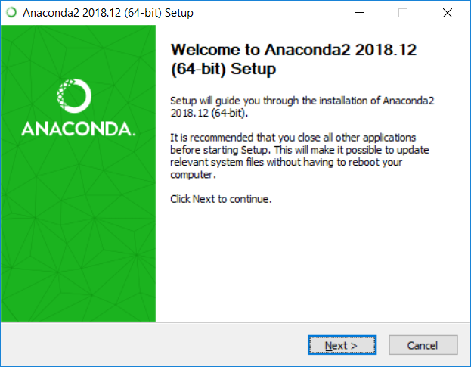

* Have a great time reading the License Agreement and click “I Agree”

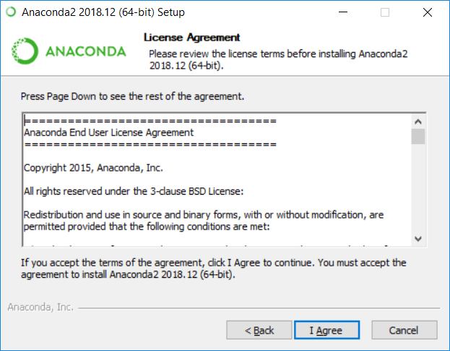

* Install for “Just Me”

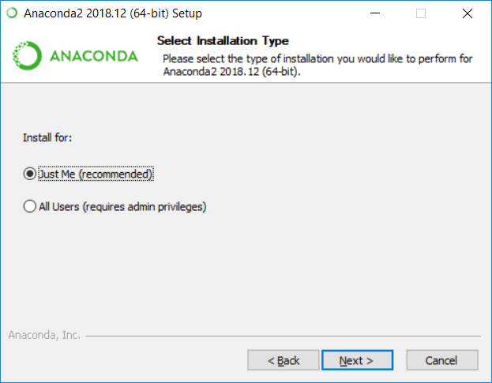

* Choose the installation directory (and take a note of it)

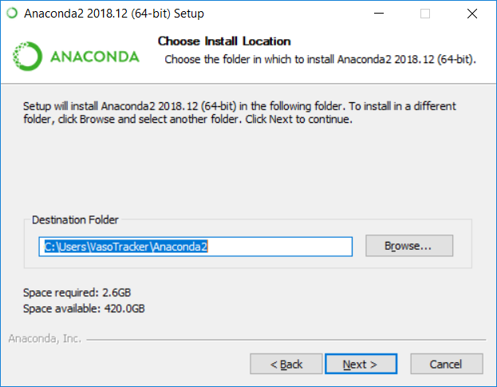

* Register Anaconda as the default Python 2.7 (but **do not** add Anaconda to the PATH environment variable!)

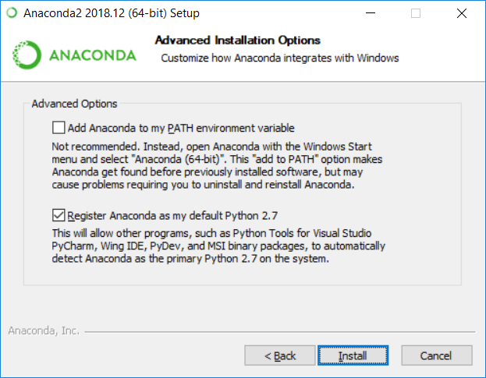

* Have two cups of tea whilst Anaconda installs

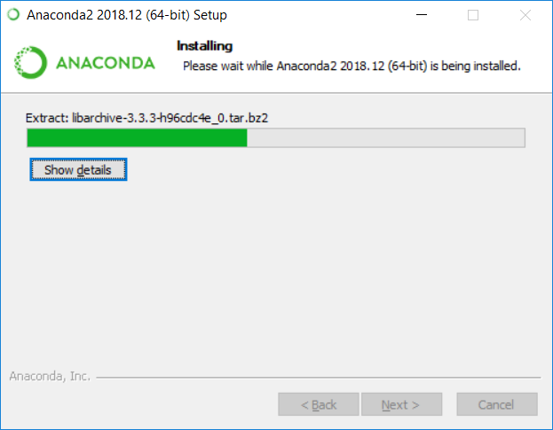

* If you want to edit the code, install Microsoft Visual Studio Code

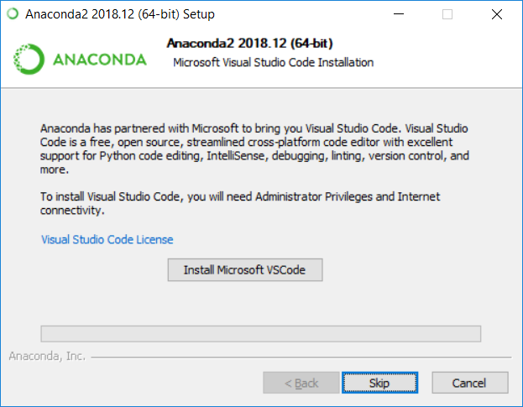

* Click “Finish”

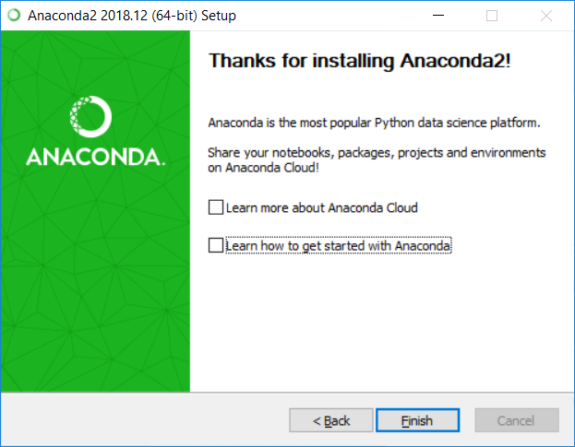

* Anaconda runs through a special command prompt. It is best to set this to run as administrator. First, locate the folder containing the Anaconda Prompt (search for “Anaconda Prompt” in windows search bar, right click, open file location)

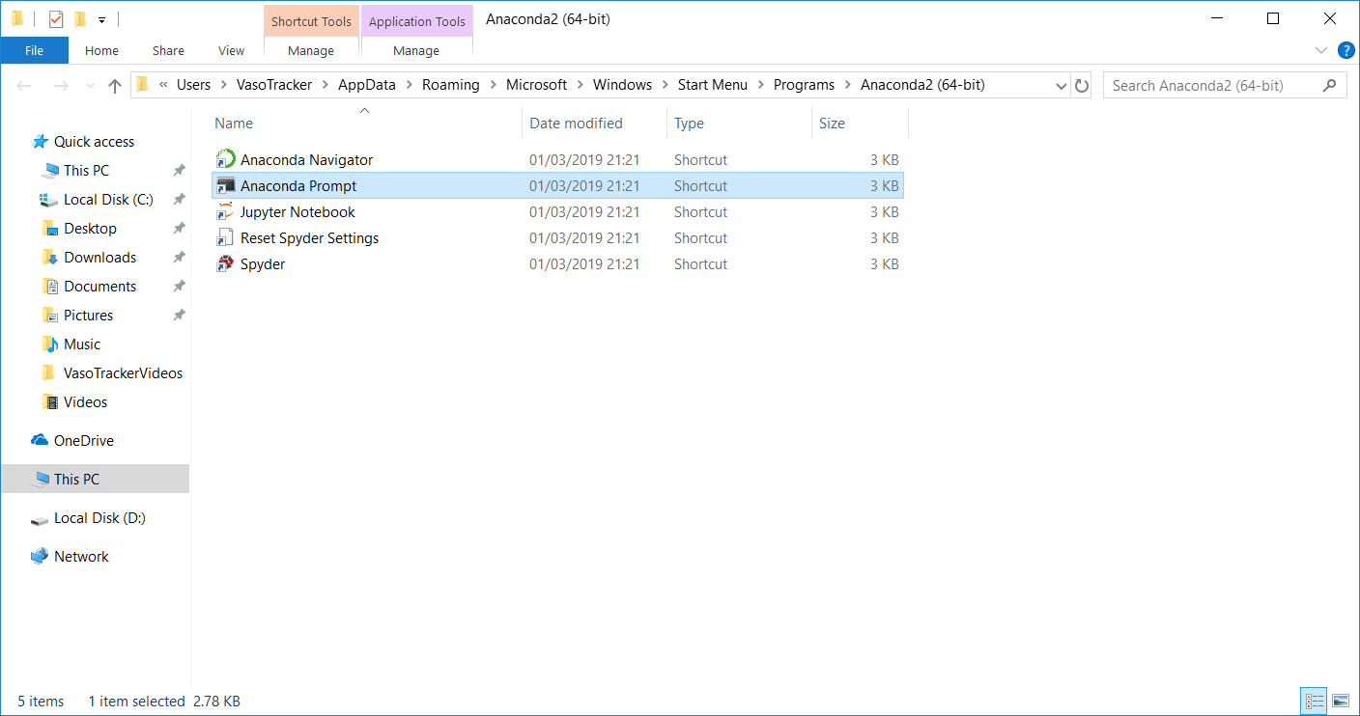

* Right click on the anaconda prompt shortcut (you could also send this shortcut to the desktop, but perform the steps below by right clicking on the desktop shortcut)
* Click properties and open Shortcut tab, then click “Advanced” button

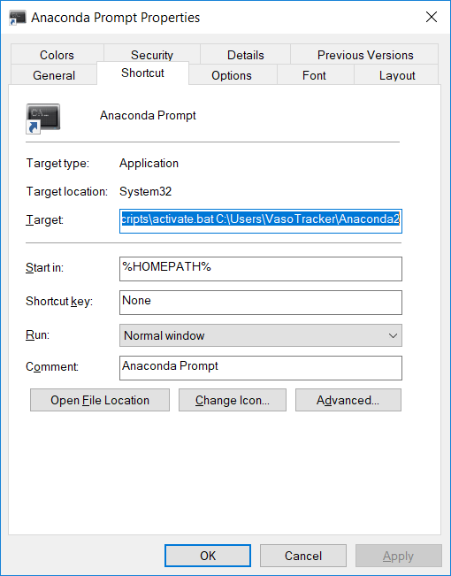

* Check “Run as administrator”

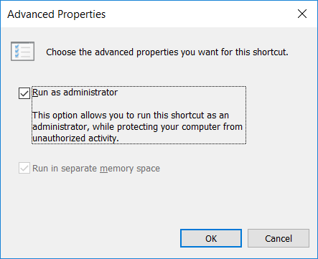

## Installing Python dependencies

The recommended Anaconda distribution comes with most of the Python packages that are required by VasoTracker. Two packages must be installed separately, OpenCV and pyserial.

### Installing OpenCV 3.4.1

* Download the OpenCV packaged (.exe file) from the official OpenCV site:

<https://sourceforge.net/projects/opencvlibrary/files/opencv-win/3.4.1/opencv-3.4.1-vc14_vc15.exe/download>

* Install OpenCV to C:/OpenCV/
* From the OpenCV directory, copy “cv2.pyd” from:

C:\opencv\build\python\2.7\x64

to the following Anaconda directory:

C:\Users\%Username%\Anaconda2\Lib\site-packages

|  |  |
| --- | --- |
|  | **The Anaconda directory may be in the C:Users\AppData hidden folder. We told you to take a note of it!** |

### Installing pyserial

* Launch Anaconda Prompt

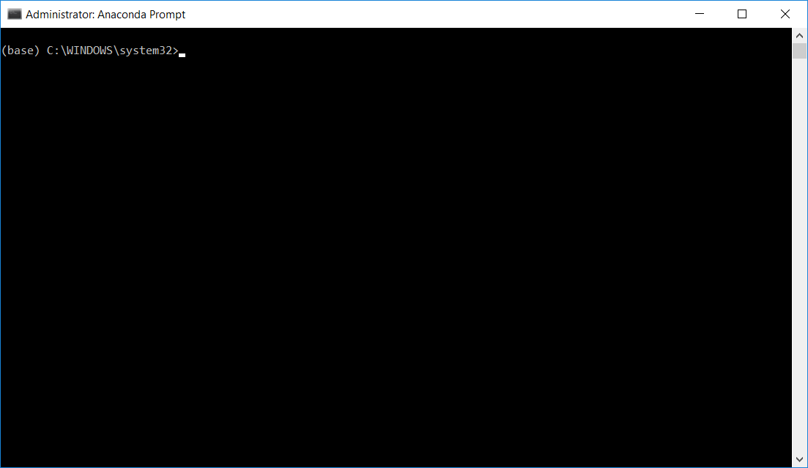

* Type the following command into the terminal and hit enter:

pip install pyserial

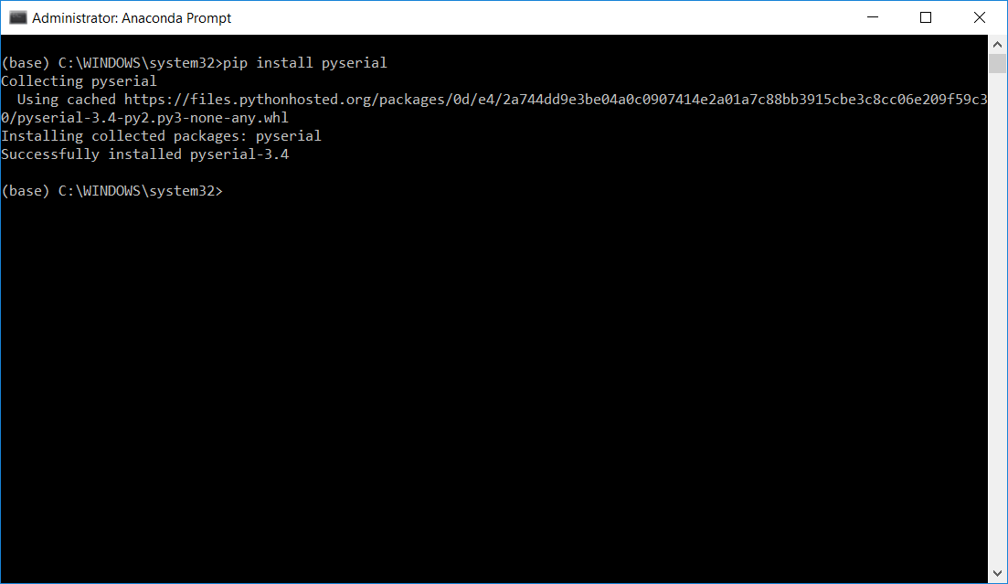

|  |  |
| --- | --- |
|  | **Congratulations if you made it this far, you should now be able to adapt the VasoTracker source code using Visual Studio Code, or any other editor.** |

## Launching VasoTracker from the source code

VasoTracker should be launched from the Anaconda Prompt.

* Launch Anaconda Prompt
* Navigate to the VasoTracker source code folder using the “cd” command, by typing the following into the prompt and hitting enter:

cd c:\VasoTracker-master\VasoTracker_Software\Source

* Launch VasoTracker by typing the following into the prompt and hitting enter:

python vasotracker.py

|  |
| --- |
| www.vasotracker.com |